**NOTES:**

No validation was implemented in this exercise. The is assumed the user shall provide the correct data type for the input. Since our module topic is about “functions” all solutions are implemented using functions. Below is the first few lines of the code:

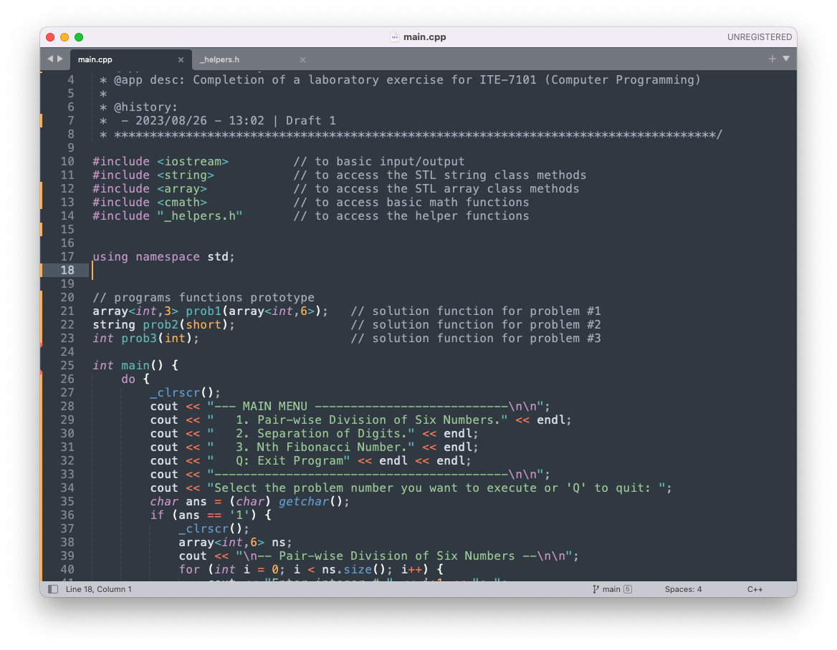

**Problem 01**

Write a program that can divide six non-zero integers (two integers per division) from the user and display the result to the user. Create a function that will perform the division operation.

**Solution and Testing 01**

Here we made use of STL array to take the input form the user and another STL array as output of the function.

Below is the screenshot of the solution program as well as testing in the terminal.

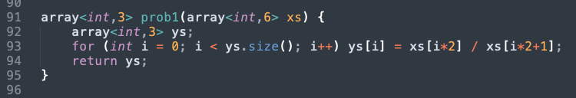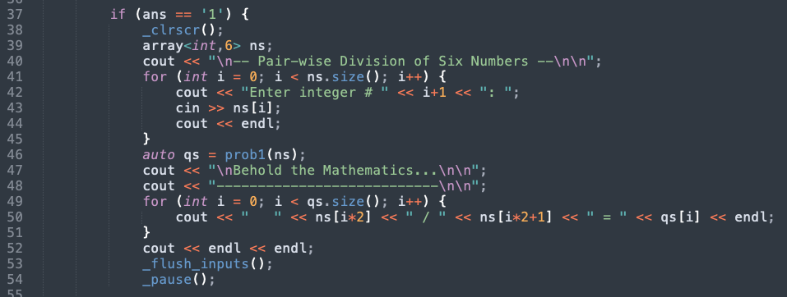

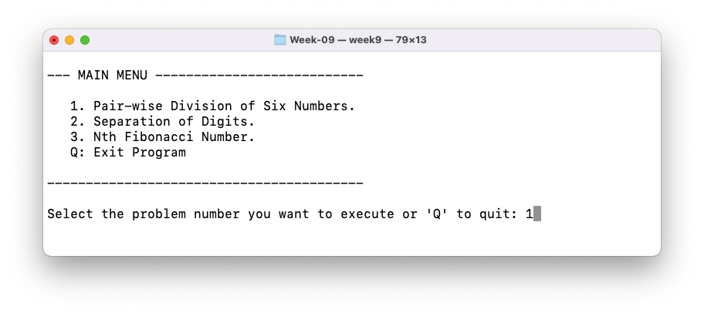

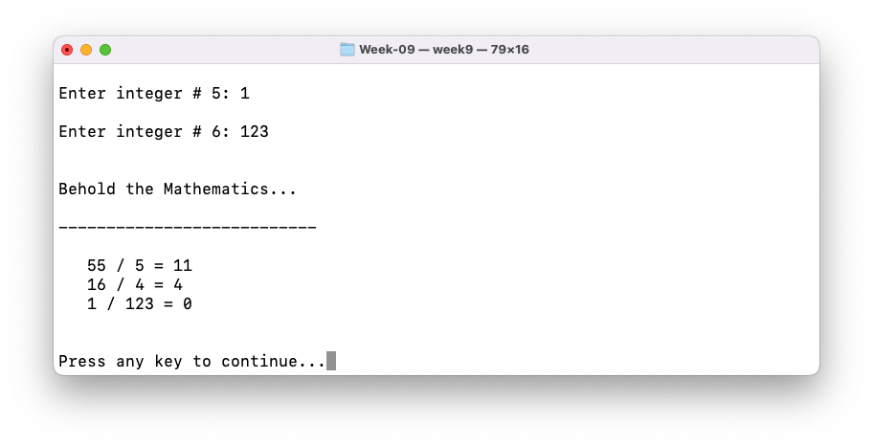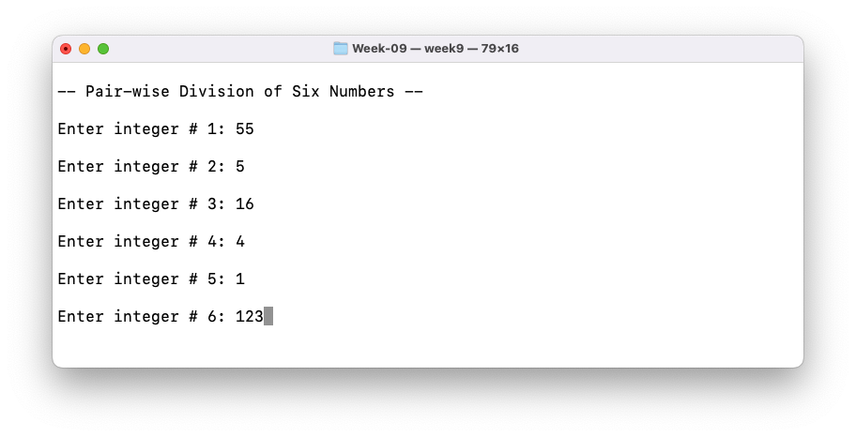

**Problem 02**

Write a program that will accept a short value from 10 to 99 and display them per digit (separated by a space).

**Solution and Testing 02**

Here we take a short int, cast it into an int and convert it to a string using string method “to_string()”. We then insert spaces in between the resulting string. Actually, our program will work for any short integer.

Below is the screenshot of the solution program as well as testing in the terminal.

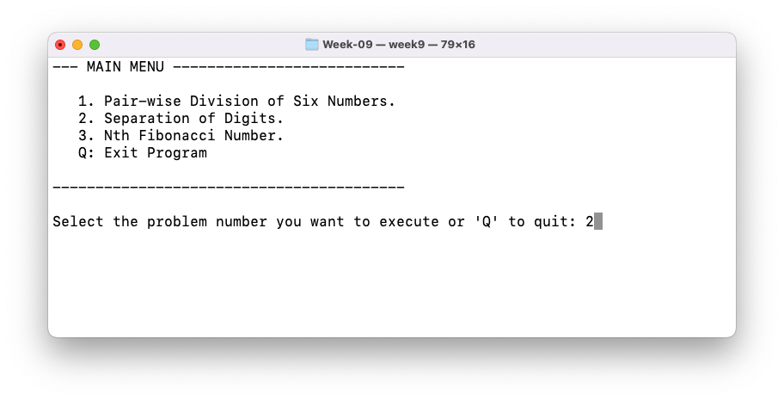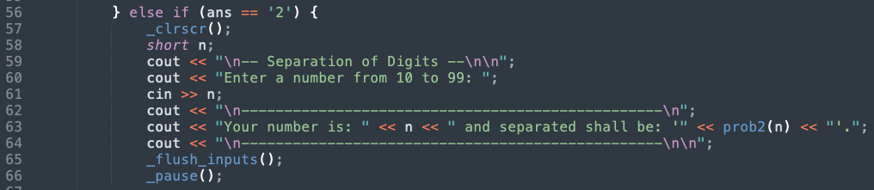

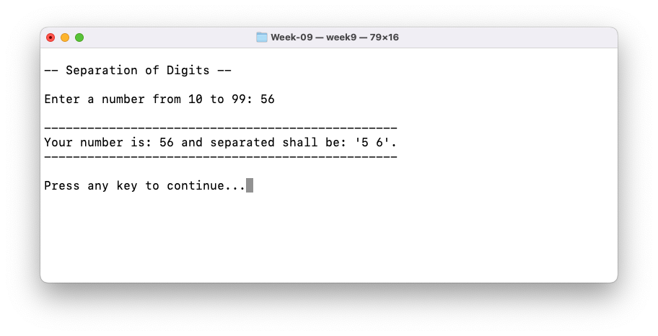

**Problem 03**

Write a program that will display the nth Fibonacci number. Create a function that will generate the nth Fibonacci number. Fibonacci numbers are numbers from the Fibonacci sequence which follows the pattern of 1, 1, 2, 3, 5, 8, 13, 21, 33, 54…

**Solution and Testing 03**

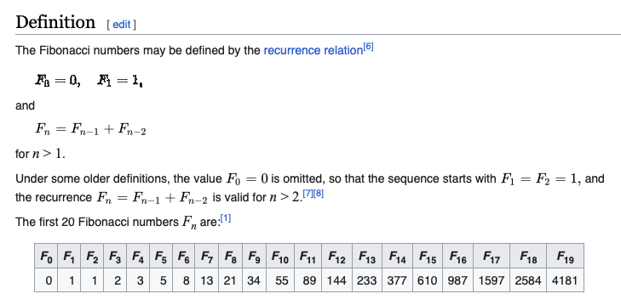Wikipedia has the following definition for [Fibonacci Numbers](https://en.wikipedia.org/wiki/Fibonacci_sequence#Definition):

Therefore, the problem should have been written as:

“*Write a program that will display the nth Fibonacci number. Create a function that will generate the nth Fibonacci number. Fibonacci numbers are numbers from the Fibonacci sequence which follows the pattern of 1, 1, 2, 3, 5, 8, 13, 21, 34, 55…*”

We will use the famous “[Binet’s Formula](http://www.milefoot.com/math/discrete/sequences/binetformula.htm#:~:text=The%20explicit%20formula%20for%20the,of%20sequences%20in%20number%20theory.)”, to propagate the Fibonacci sequence. Binet’s Formula is capable of O(1) run time and therefore, suitable for large Fibonacci numbers.

Below is the screenshot of the solution program as well as testing in the terminal.

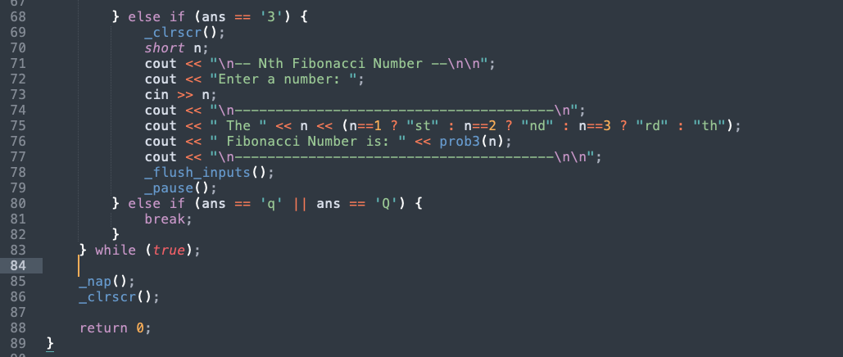

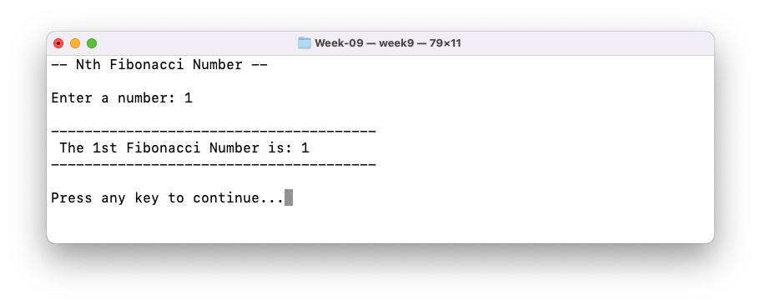

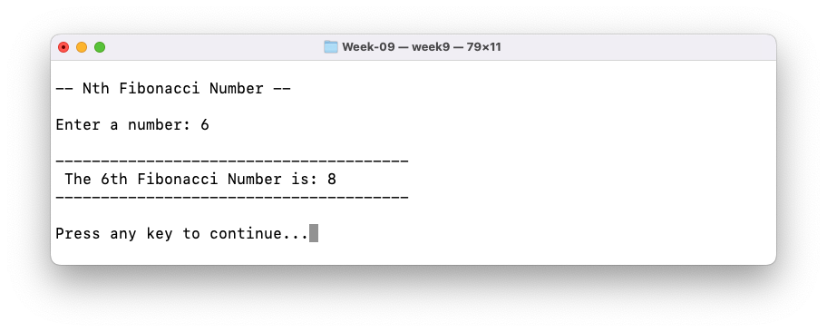

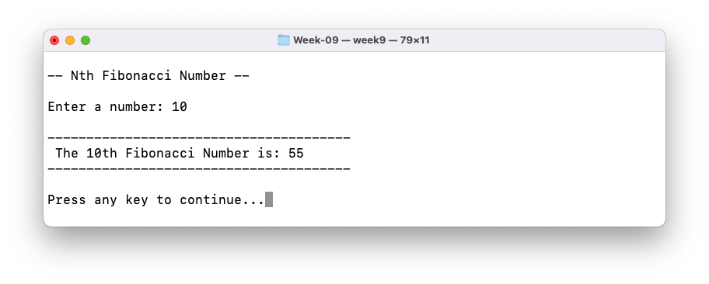

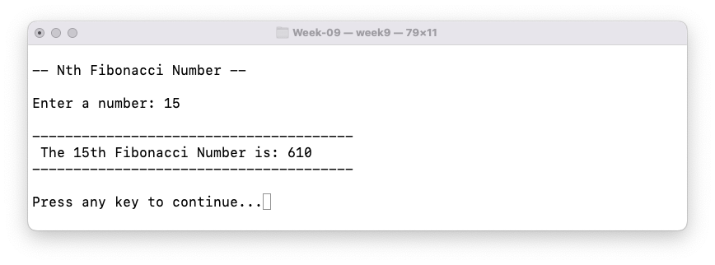

**Problem 04**

What can you conclude from this activity?

**Answer 04**

The solutions presented may not be the exact solutions the problem creator had in mind. But the solutions work, and do **satisfy the problem specification**. There is always more than one way to solve a programming problem.

With regards to our comment in problem 3, if we are the client and we are to make a programming specification, we should make sure our definitions are correct so as not to confuse the programmers.

------------------------

**NOTE FOR THIS PROBLEM:**

Source code can be found on my GitHub page: <https://github.com/rvillamangca/>.